**Chatbot using DialogFlow**

1. **Introduction:**

A chatbot is an application that can initiate and continue a conversation using auditory and/or textual methods as a human would do. A chatbot can be either a simple rule-based engine or an intelligent application leveraging Natural Language Understanding. Many organizations today have started using chatbots extensively. Chatbots are becoming famous as they are available 24*7, provide a consistent customer experience, can handle several customers at a time, are cost-effective and hence, result in a better overall customer experience.

1. **Building a chatbot using google DialogFlow**

* Sign up for dialogflow for free and create an account.
* Go to console
* Create an agent (An agent is a virtual agent or bot that handles the conversation with end-users. We can design or build a Dialogflow agent to handle the different types of communications required by the system. These can be included in any app, product, or service and transform natural user requests into actionable data)

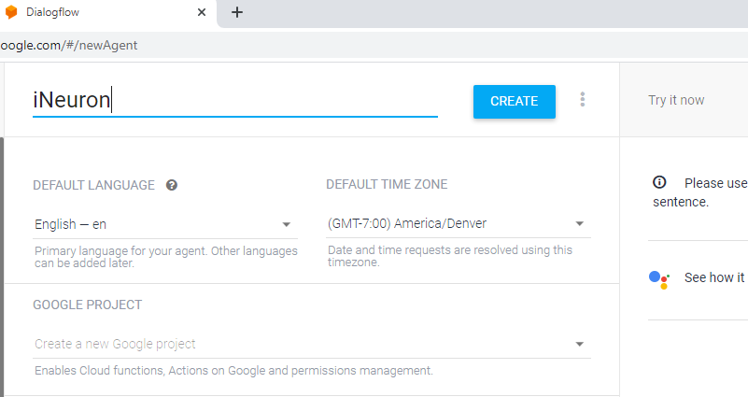

* Now Create intent (Intents are mappings between a user's queries and actions fulfilled by our software.)
* Click save.

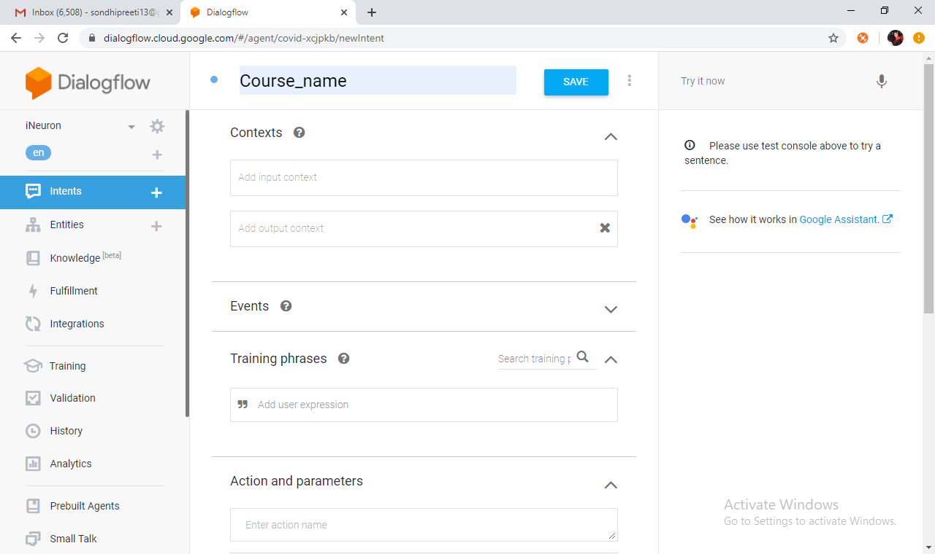

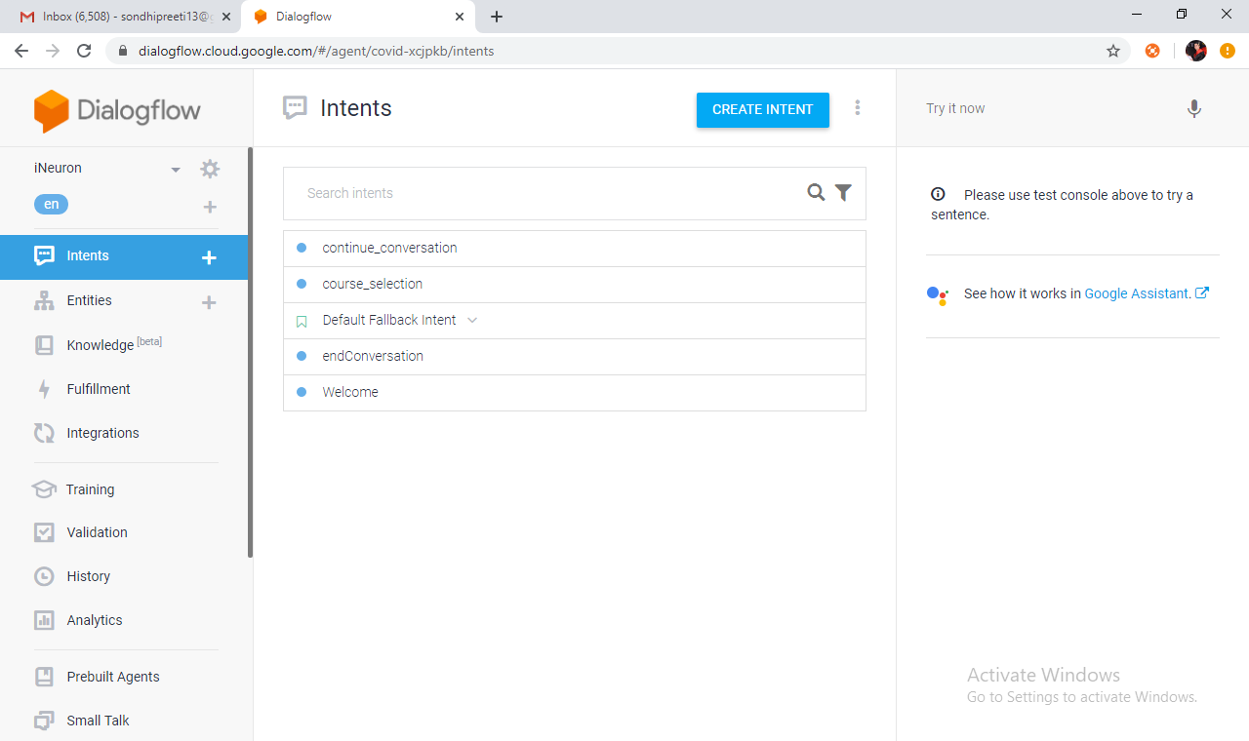

* Click on ADD TRAINING PHRASE and then add Training phrases. Training phrases are examples of what users can say to match a particular intent. Adding numerous phrases with different variations and parameters will improve the accuracy of intent matching.

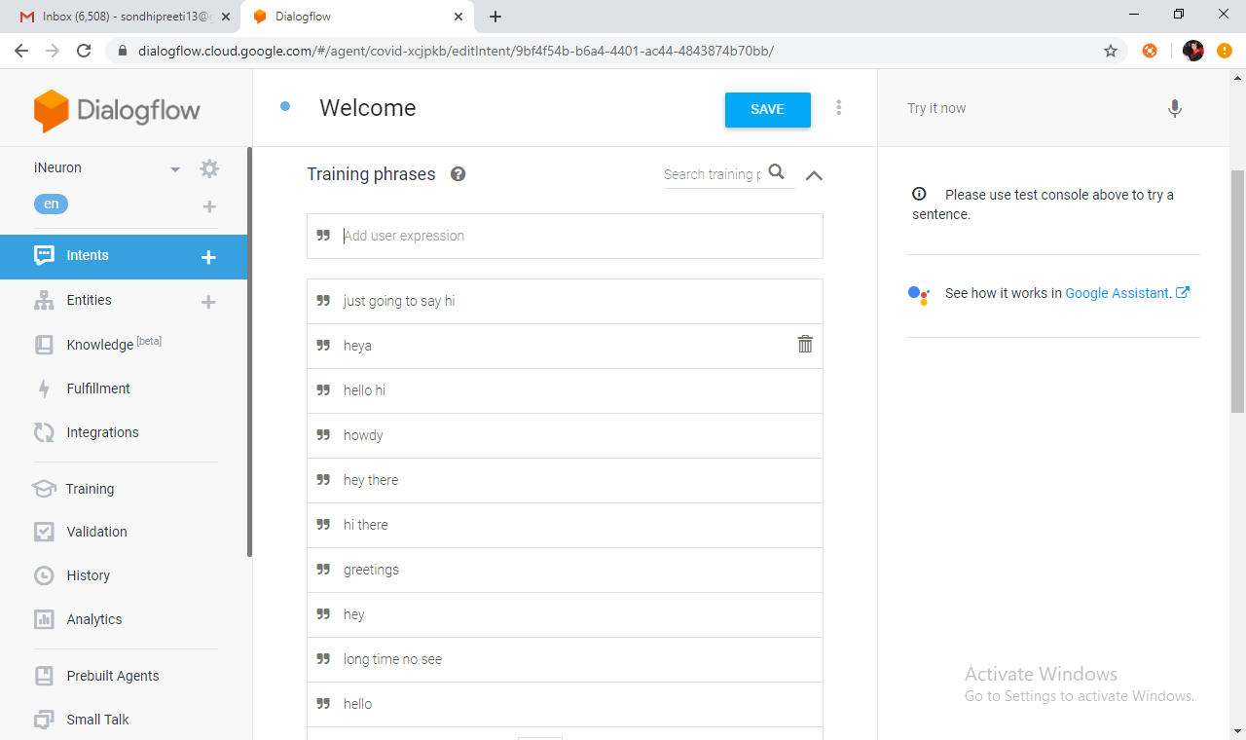

* Select the system entities. This step involves identifying the purpose of the user conversation and saving the data to improve communications. We can even create our own entities.
* Action and Parameters: The inputs we need from the user to act on the user request. e.g., consultation. Examples are dates, times, names, places, and more.

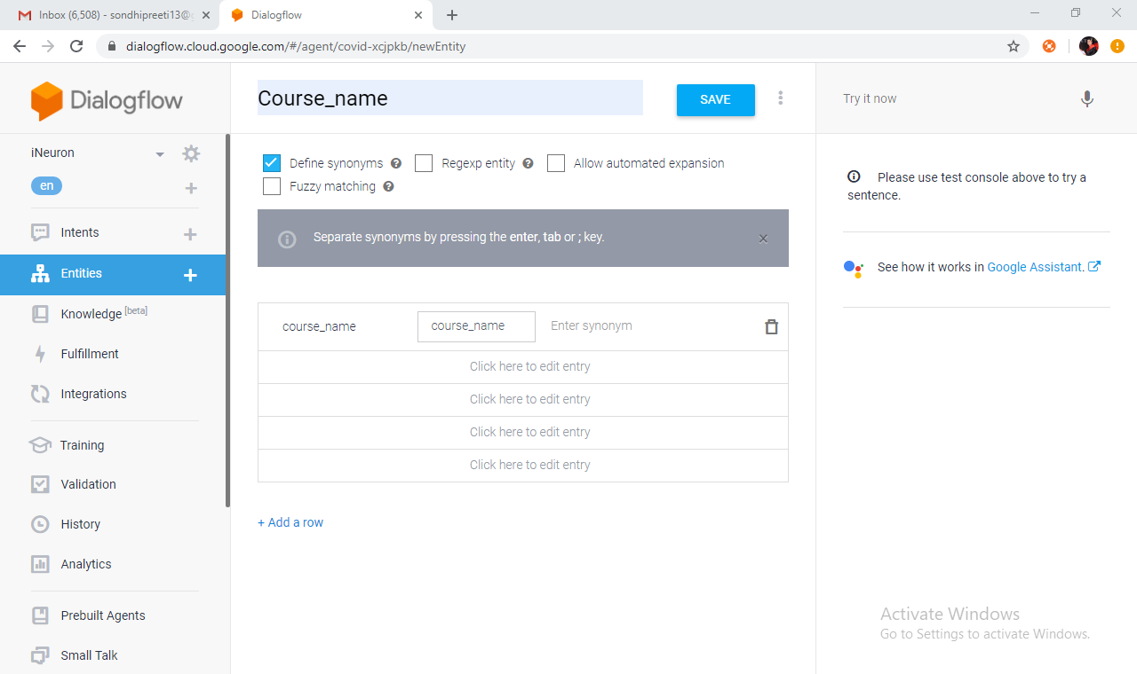

Click on ADD RESPONSE to provide an appropriate reponse to user queries

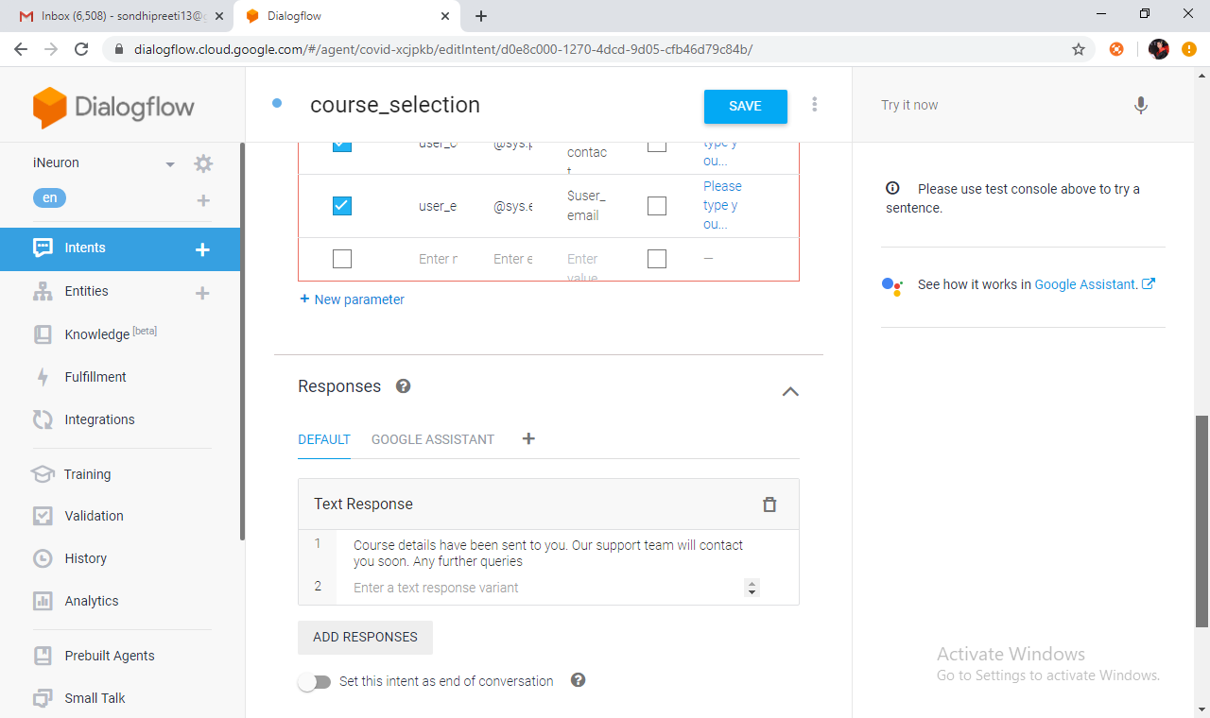

* Click save.
  1. **Fulfillment**

Fulfillment helps to use the information extracted by Dialogflow's natural language processing to generate responses dynamically or to trigger actions in the back-end. a. Configure fulfillment: i. Enable fulfillment by sliding Enable webhook call for this intent to the intents, which involve some logic building or to trigger actions.

To enable the inline editor, Click on Fulfillment in the left menu. Click the switch for Inline Editor

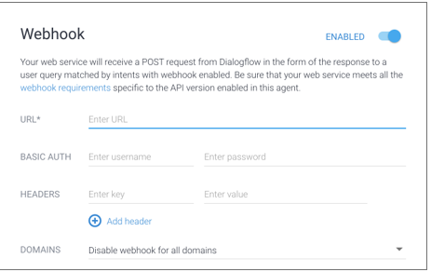

**Fulfillment request and response:** click diagnostic info and get fulfillment request .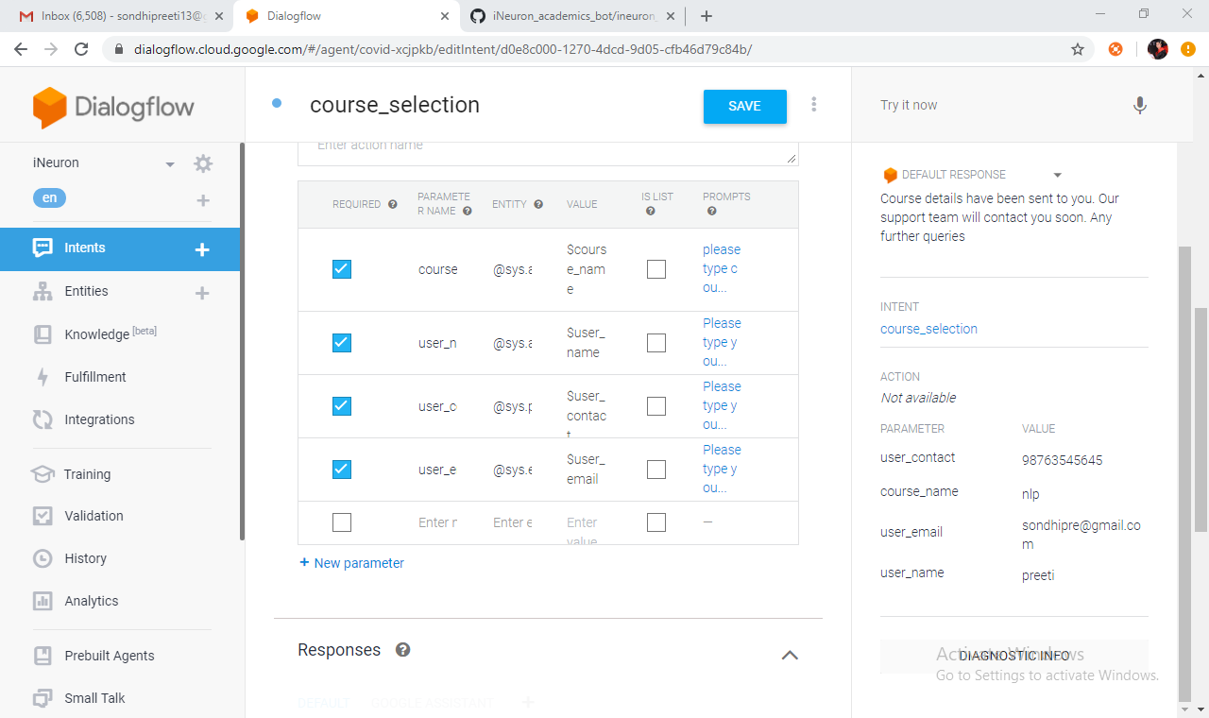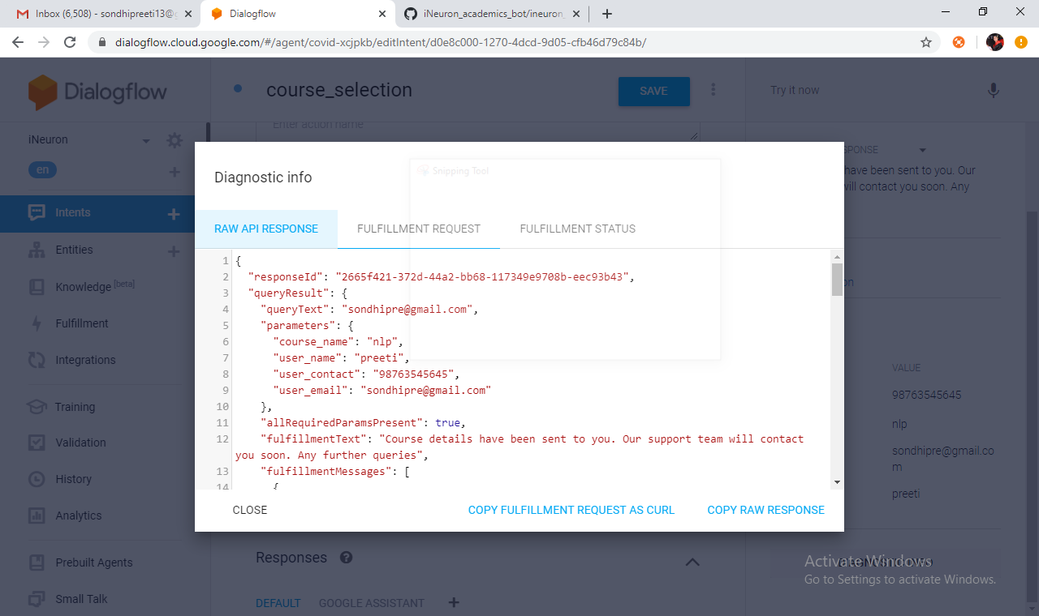

**3) Create Python app and integrate with dialogflow**

* Create a folder and open that folder in pycharm.
* Open app.py.
* Config.ini includes default values of sender email, password, email body, subject and support team email id.

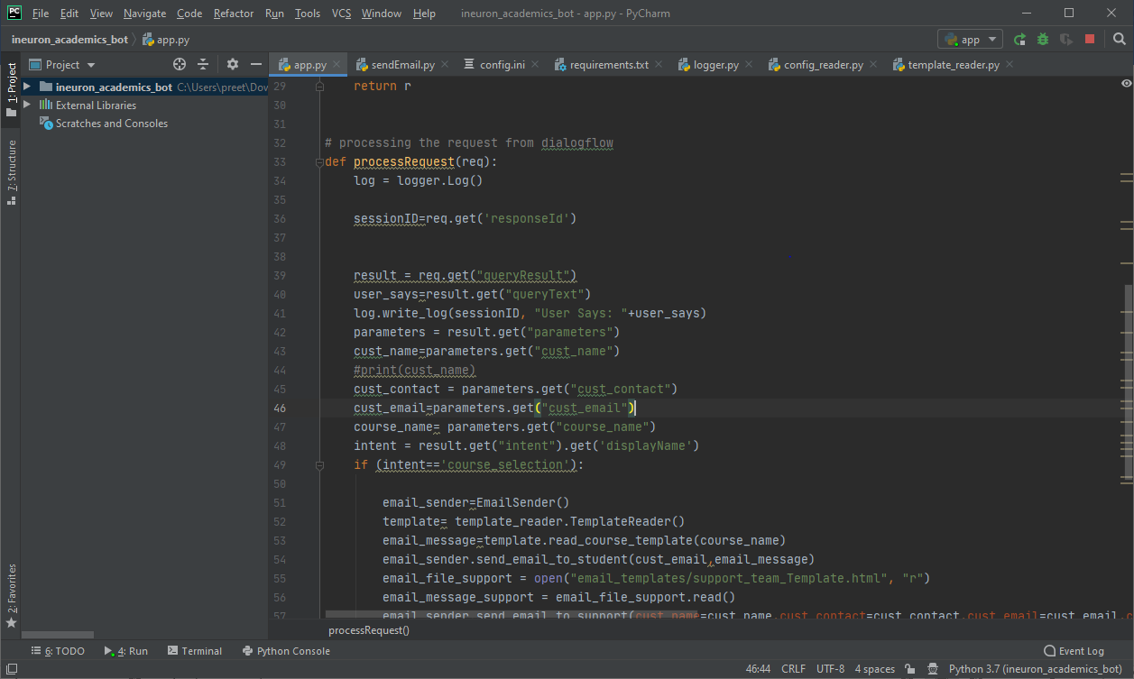

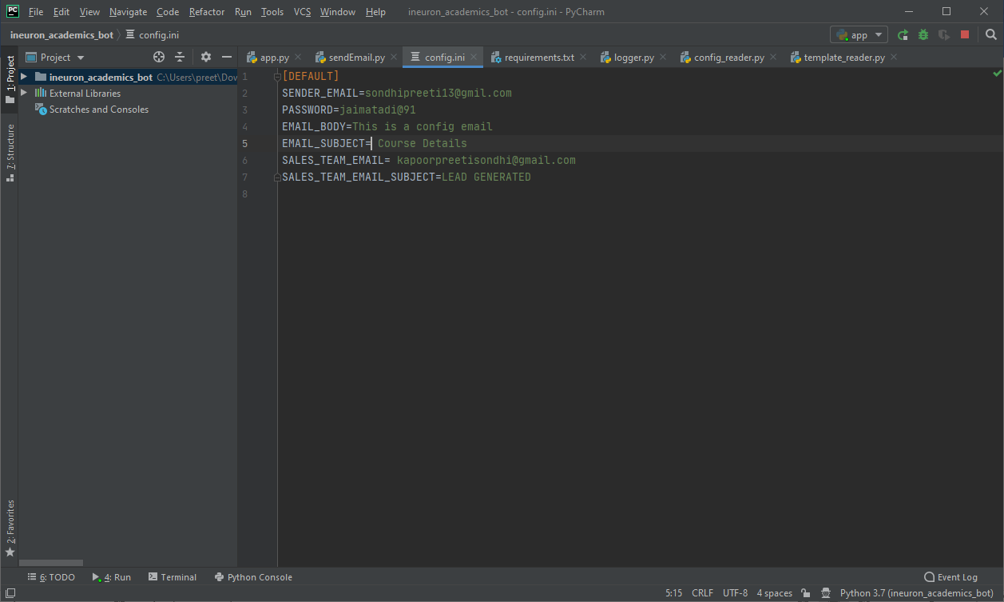

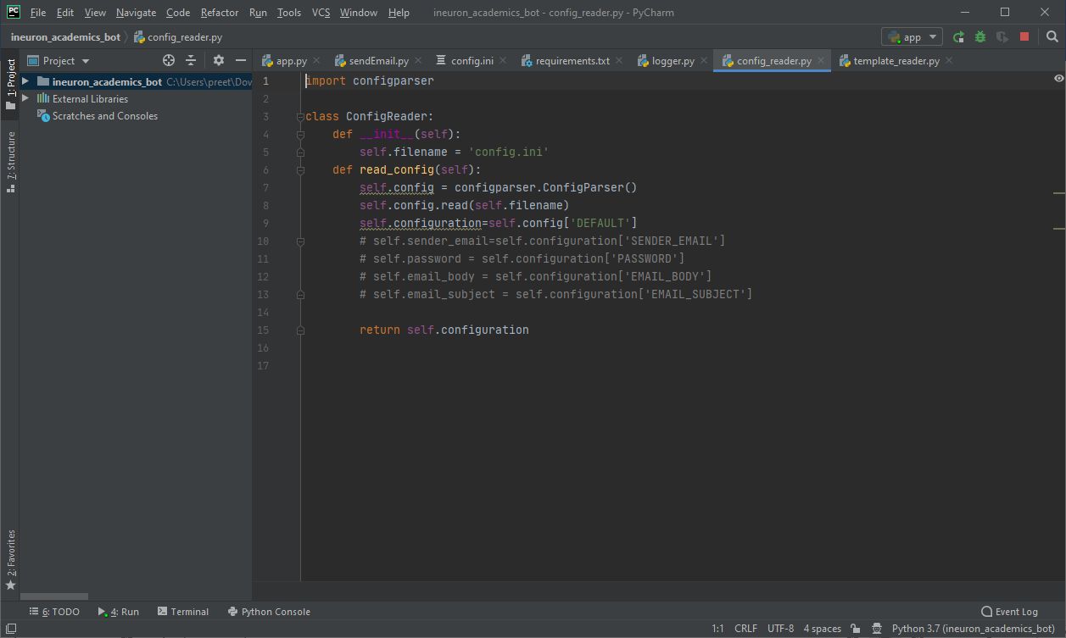

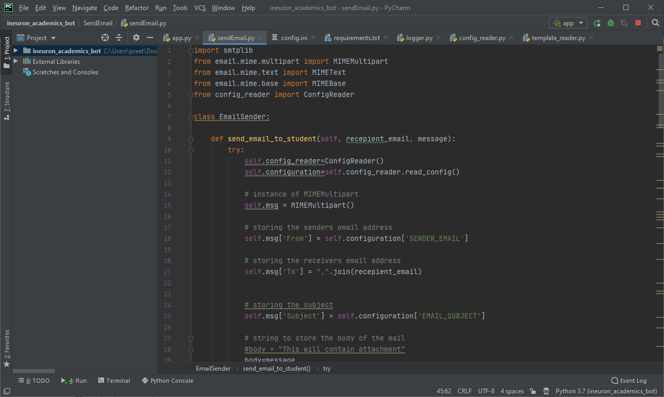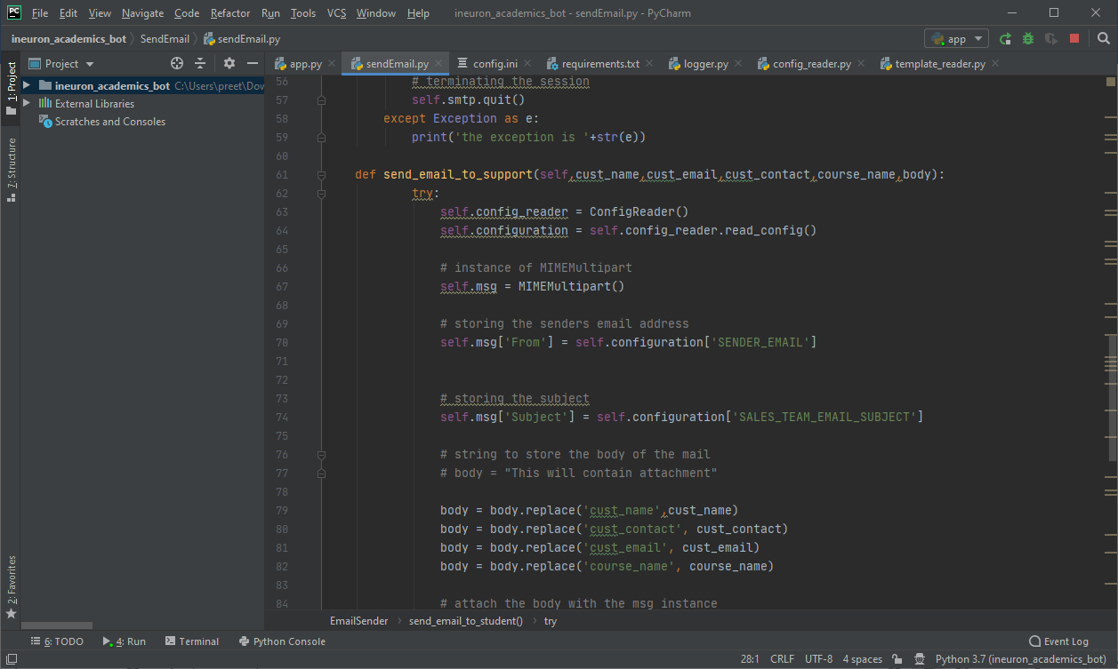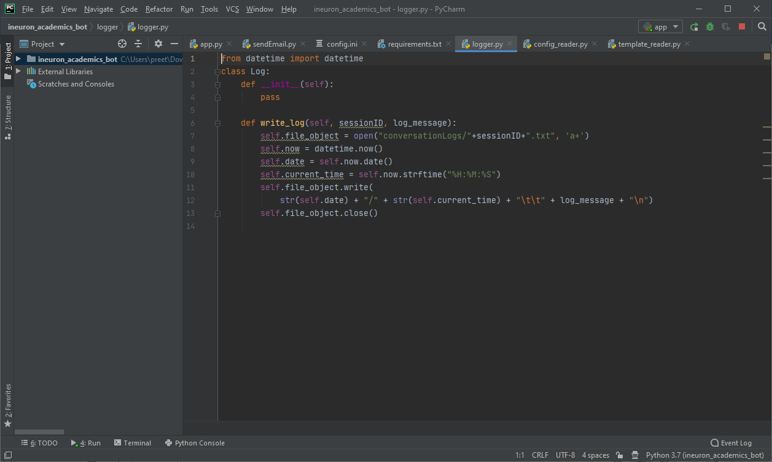

* **Testing chatbot**

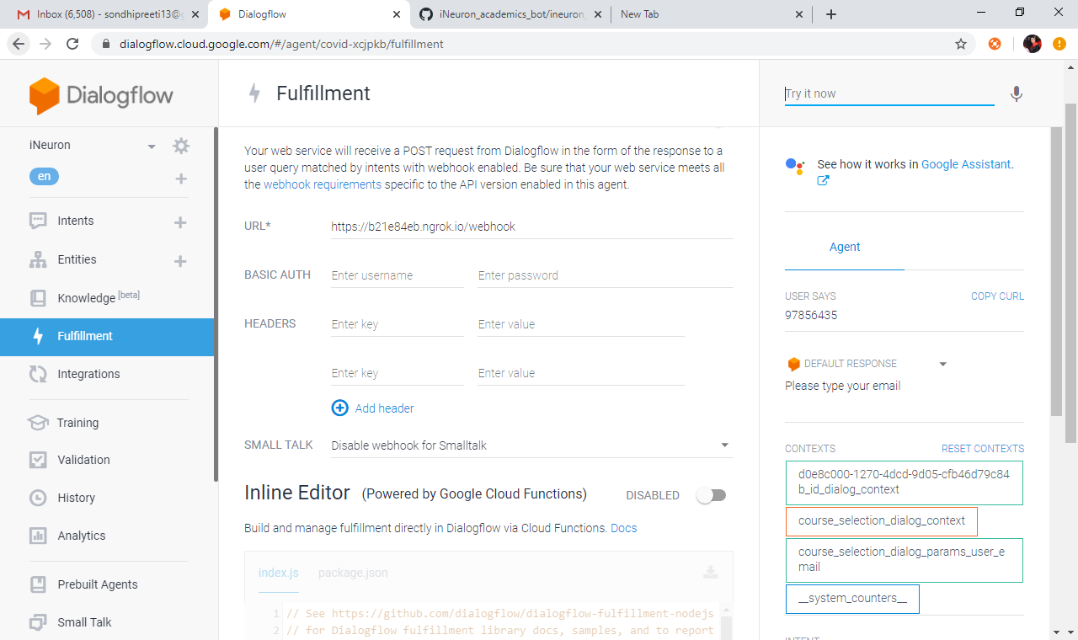

**Integration**

Go to integrations tab on the left-hand side an enable the integrations

1. **Integration with facebook**

* Click on integrations on LHS and click facebook messenger to enable the integration with facebook.

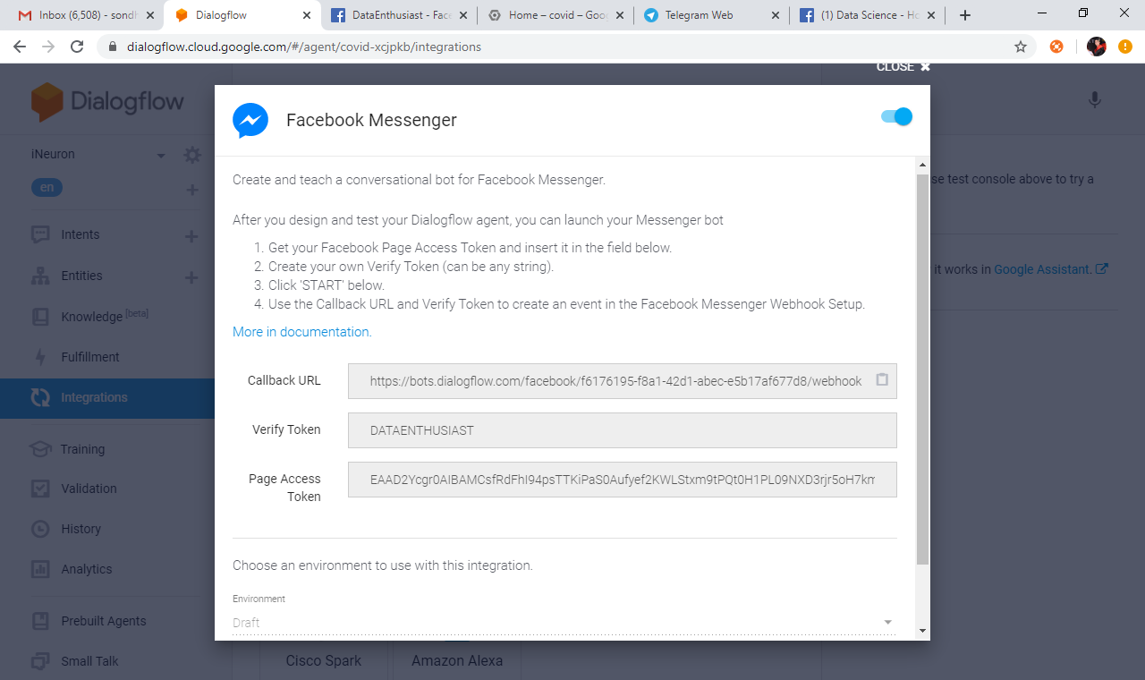

* Now create an app on facebook for developers and create a page there.
* I have created an app Data Enthusiast with page data science.
* Go to messenger on left-side and go to access token.
* Copy the token , callback url and verify token from facebook messenger and paste it in dialogflow integration with facebook.

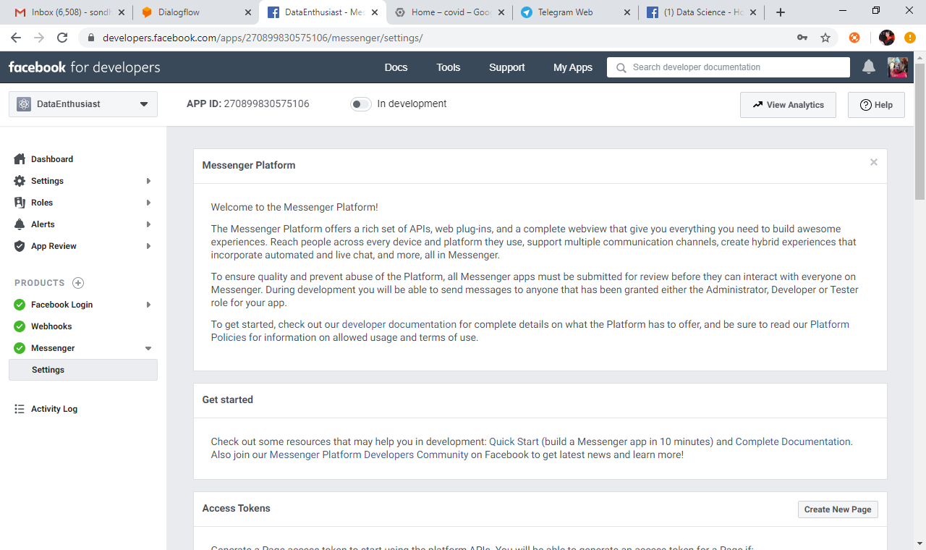

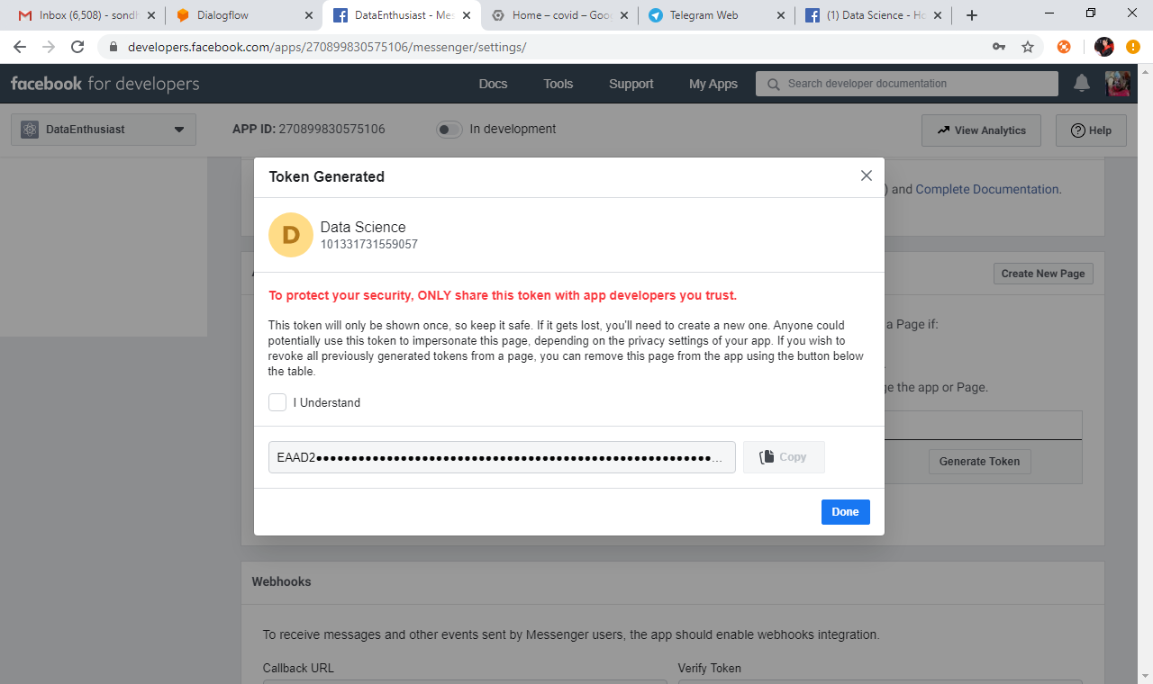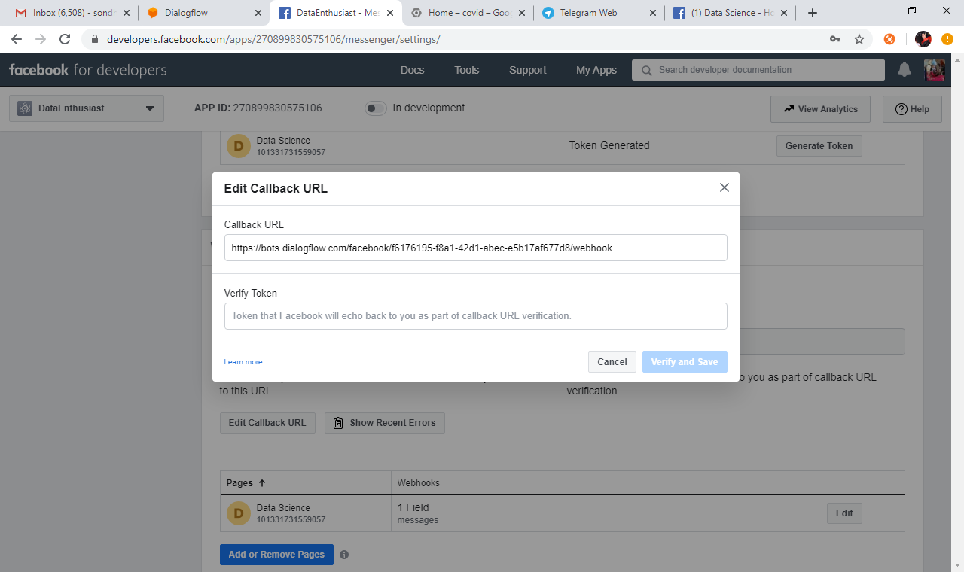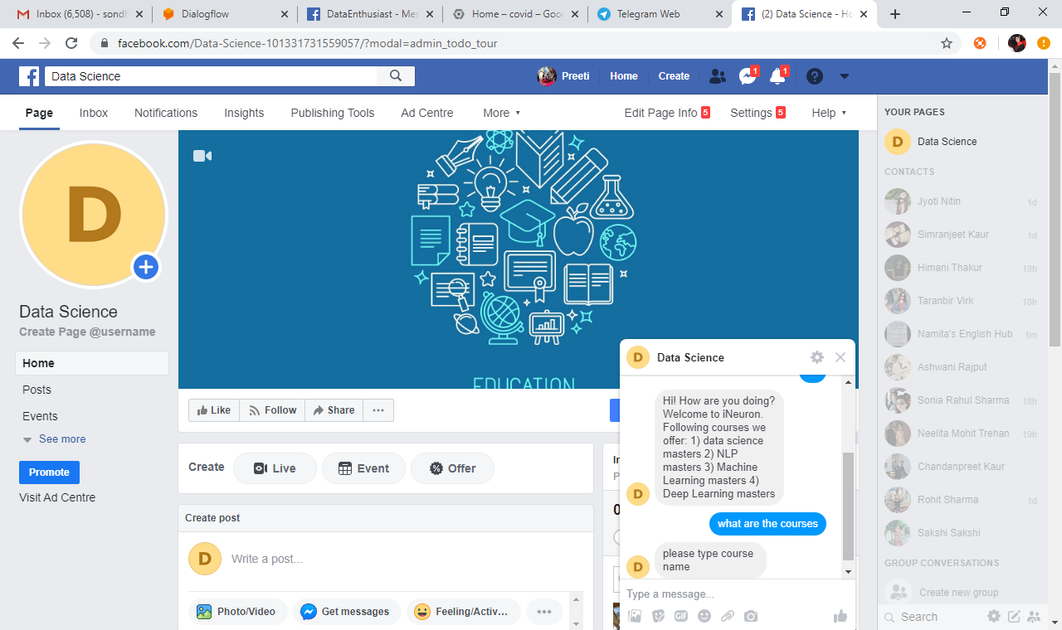

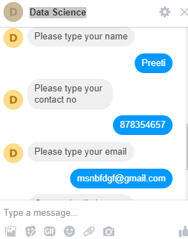

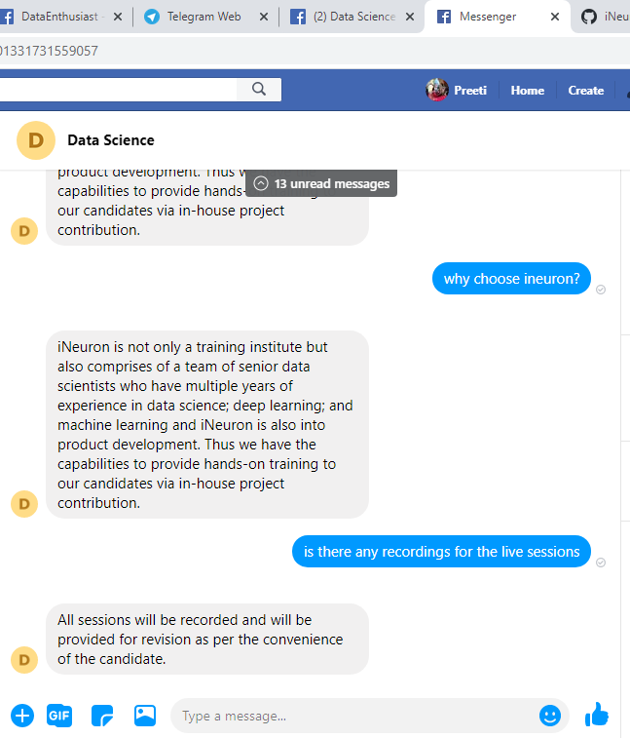

* **Integration with slack**

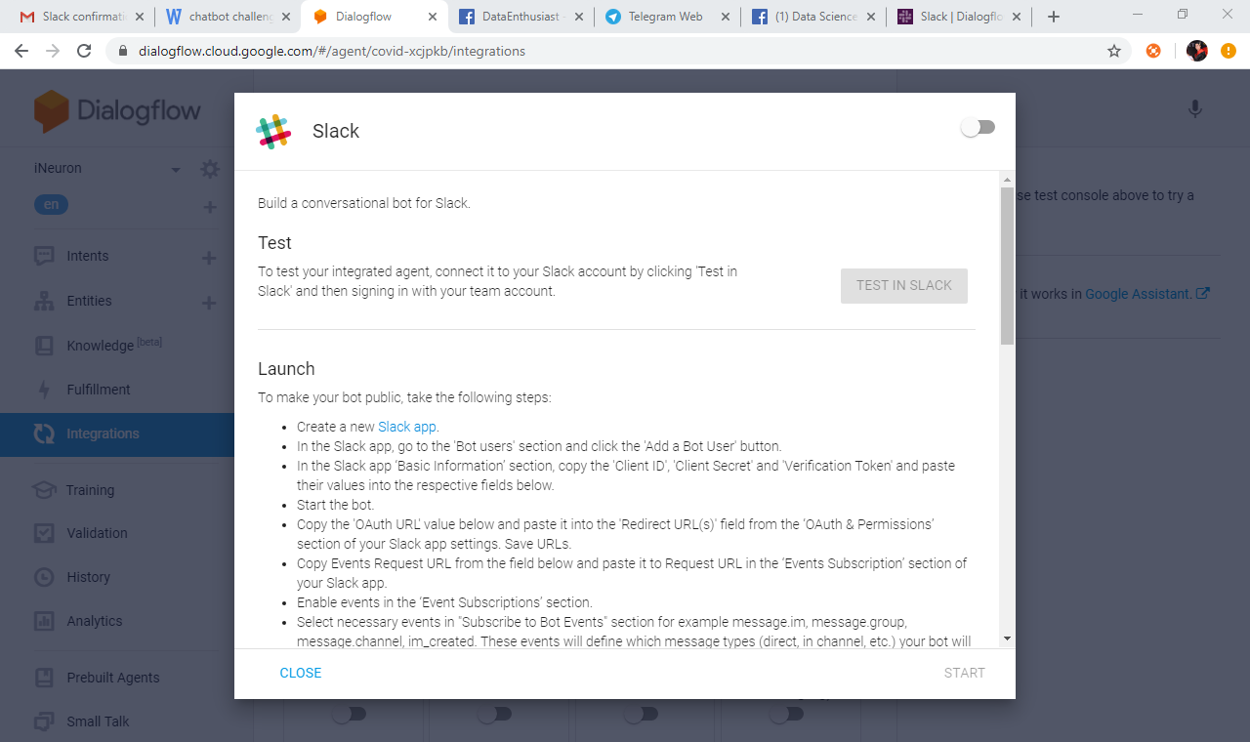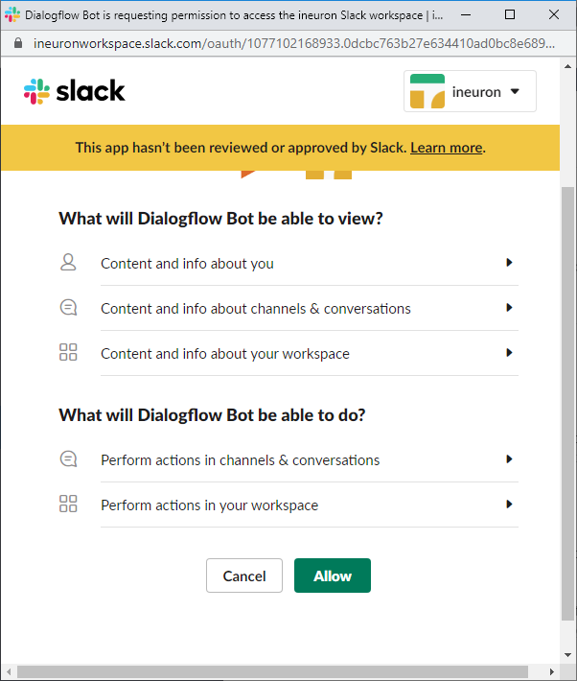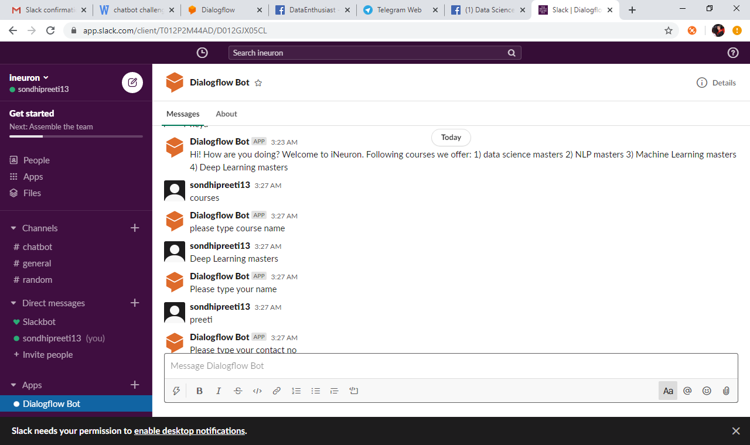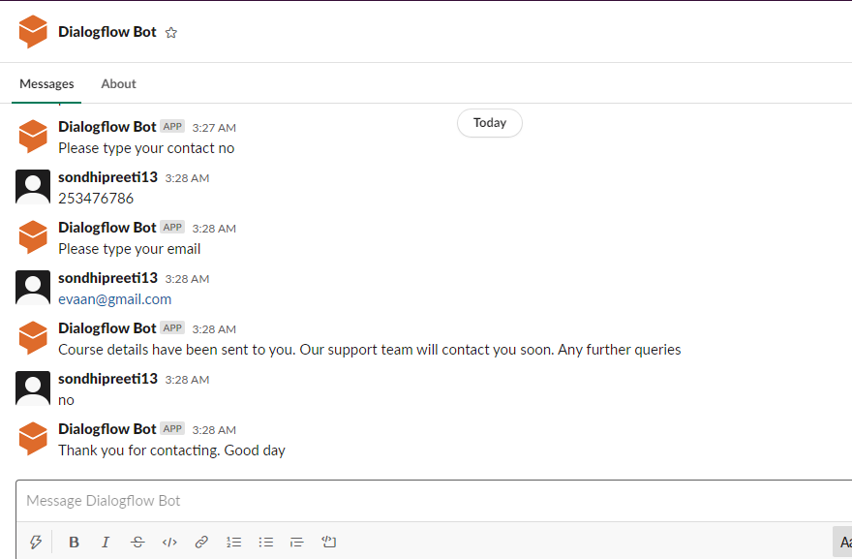

**Telegram**

To set up the Telegram integration for our agent, you'll need a Telegram account. Creating a Bot in Telegram 1. Log-in to Telegram using the link https://telegram.me/botfather 2. Click the Start button in the web interface or type /start in Telegram 3. Type /newbot and provide a name 4. Provide a username for the bot, ending in "bot" (e.g., garthsweatherbot) Copy the generated access token

5. In Dialogflow, go to Integrations available in the left-hand menu 6. Click on the Telegram tile to enable the Telegram integrations. 7. Paste the Telegram Access Token into the related field. Click the Start button

